**ASSIGNMENT 1**

**CHAPTER /TOPIC: JAVA BASICS**

**INSTRUCTIONS:**

1. Total Marks: **100**

2.Mode**: Individual**

3. Cover Page Color: **White**.

4. Submission in the form of **Soft Copy** to be submitted through eKlas.

5. Submission & presentation deadline: **March. 6, 2021**

**\*\* If you have any difficulties in submitting the assignment according to the date given, please come and discuss with me.**

**Course outcome (s):**

At the end of the course, students will be able to:

**CO1** write simple Java program using the fundamental components and control structure.

**CO2** create subclasses that inherit the properties of a given super class limited by the access modifiers.

Answer for Question 1:

Sum.java

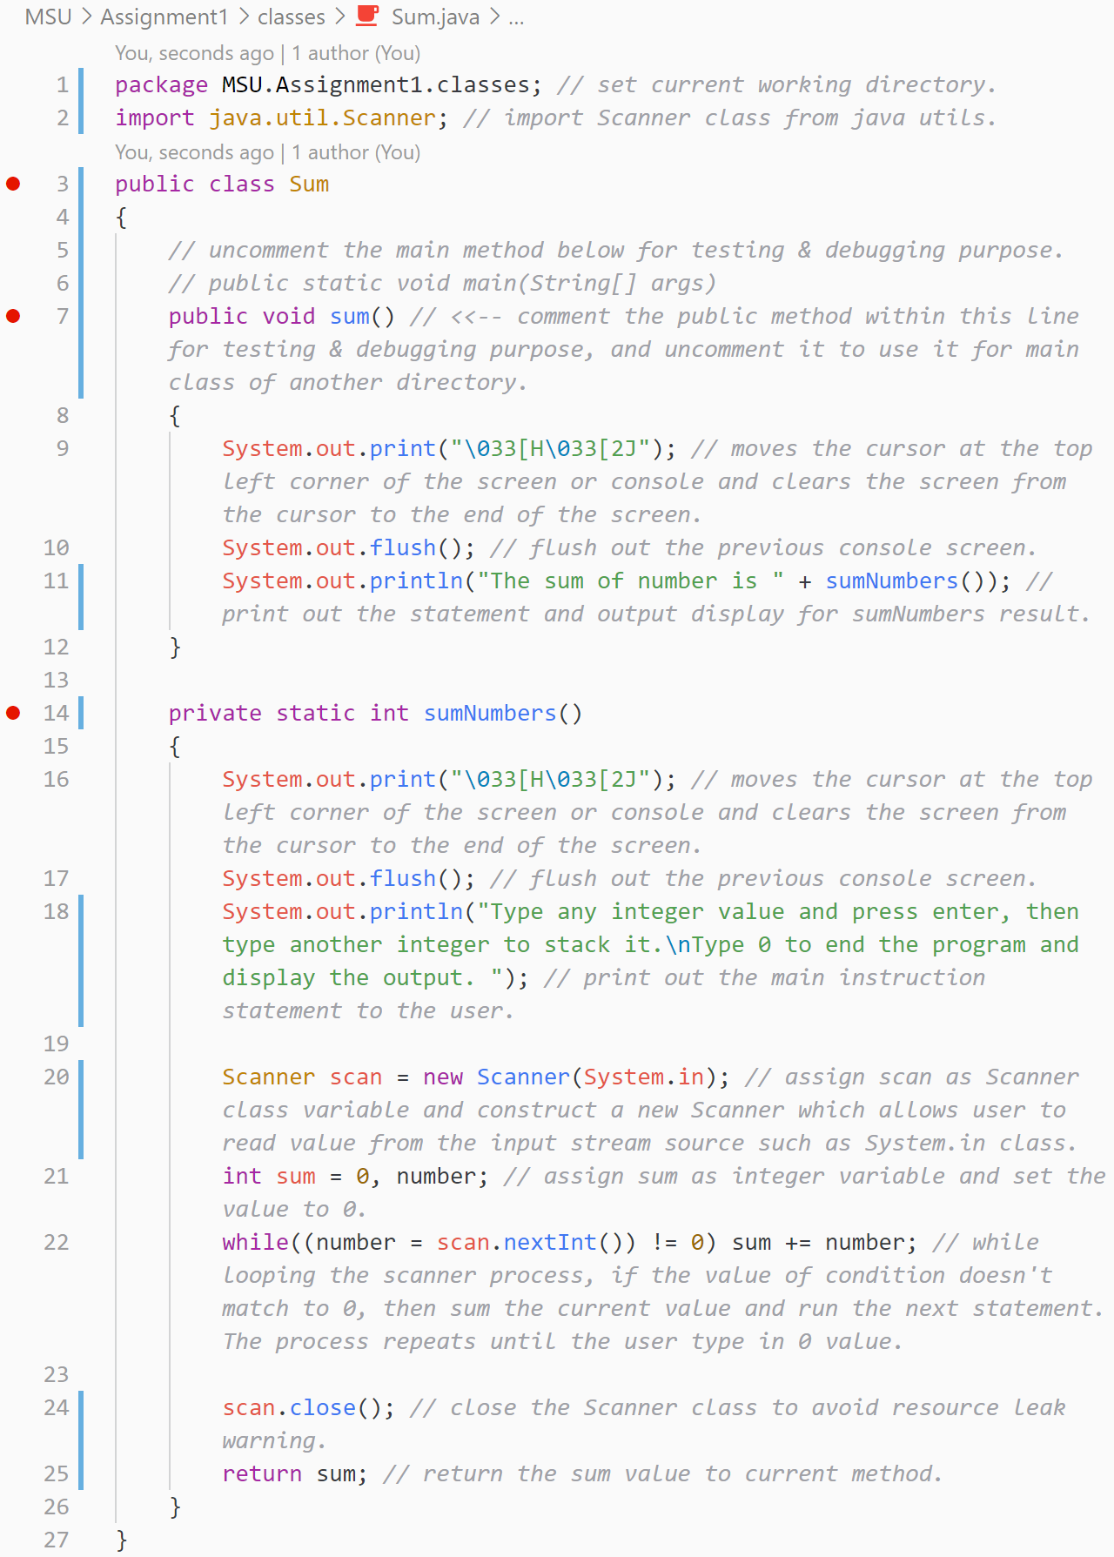

Answer for Question 2:

FahrenhietToCelsius.java

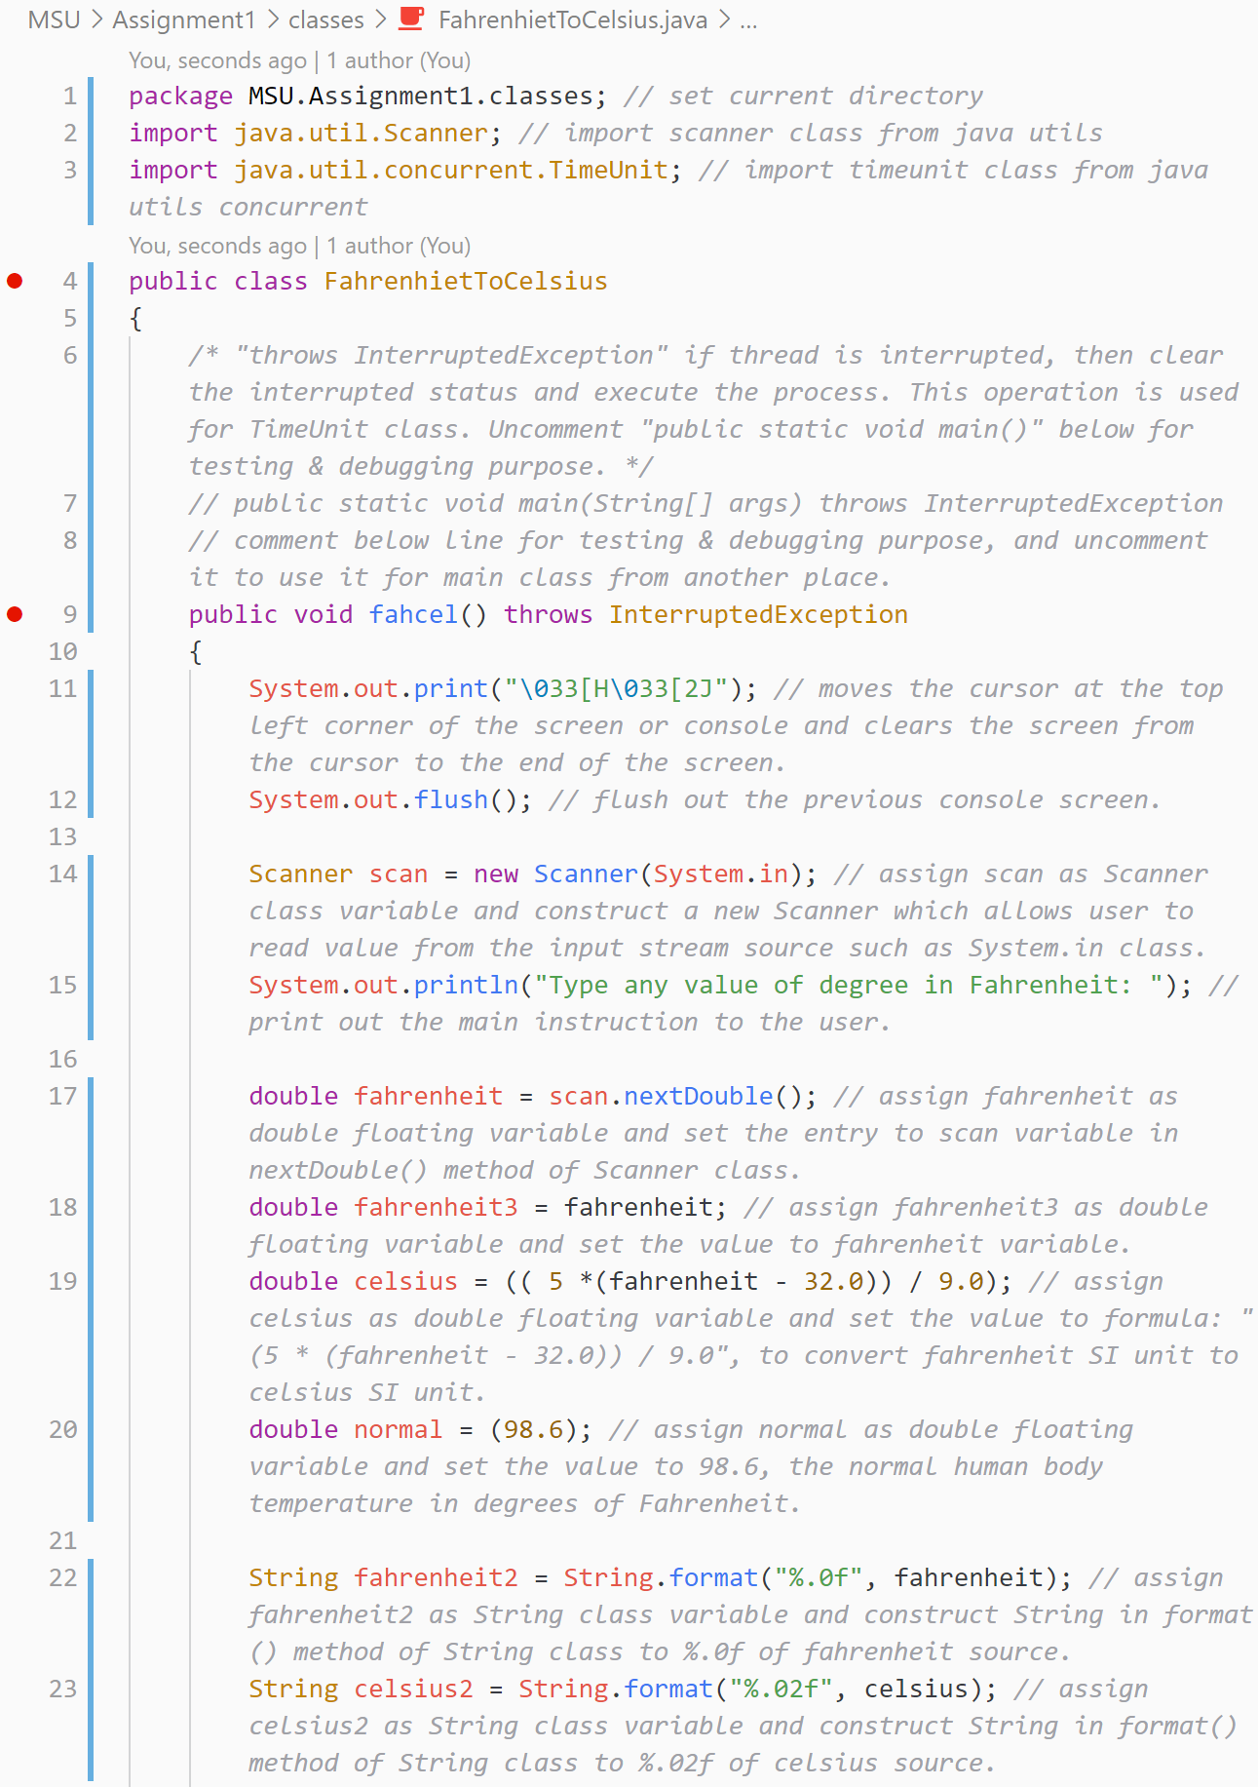

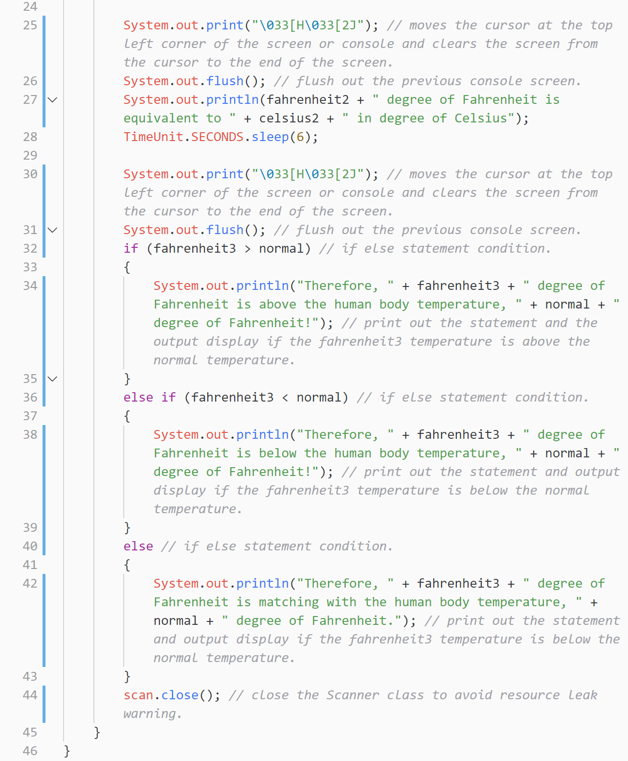

Answer for Question 3:

BMI_ifNested.java

BMI_SwitchCase.java

Answer for Question 4:

Sum.java

Answer for Question 5:

Sum.java

**Report: Assignment 1 (15%) – 75 marks Assignment 1 Rubric**

|  |  |  |  |  |  |
| --- | --- | --- | --- | --- | --- |
|  | **(1-3) Unsatisfactory** | **(4-7) Satisfactory** | **(8-11) Good** | **(12-15) Excellent** | **SCORE** |
| **Delivery** | * Completed less than 70% of the requirements. * Not delivered on time or 100% plagiarism | * Completed between 70-80% of the requirements. * Delivered on time, and 50% plagiarism | * Completed between 80-90% of the requirements. * Delivered on time, and no plagiarism | * Completed between 90-100% of the requirements. * Delivered on time, and no plagiarism |  |
| **Coding Standards** | * No name, date, or assignment title included * Poor use of white space * Disorganized and messy * Poor use of variables | * Includes name, date, and assignment title. * White space makes program fairly easy to read. * Organized work. * Good use of variables | * Includes name, date, and assignment title. * Good use of white space. * Organized work. * Good use of variables | * Includes name, date, and assignment title. * Excellent use of white space. * Creatively organized work. * Excellent use of variables |  |
| **Documentation** | * No documentation included. | * Basic documentation has been completed including descriptions of all variables. * Purpose is noted for each function. | * Clearly documented including descriptions of all variables. * Specific purpose is noted for each function and control structure. | * Clearly and effectively documented including descriptions of all variables. * Specific purpose is noted for each function, control structure, input requirements, and output results. |  |
| **Runtime** | * Does not execute due to errors. * User prompts are misleading or non-existent. * No testing has been completed. | * Executes without errors. * User prompts contain little information, poor design. * Some testing has been completed. | * Executes without errors. * User prompts are understandable, minimum use of symbols or spacing in output. * Thorough testing has been completed | * Executes without errors excellent user prompts, good use of symbols, spacing in output. * Thorough and organized testing has been completed and output from test cases is included. |  |
| **Efficiency** | * No solution | * A difficult and inefficient solution. | * A logical solution that is easy to follow but it is not the most efficient. | * Solution is efficient and easy to follow (i.e. no confusing tricks). |  |
| **TOTAL** |  |  |  |  | **/75** |

**Presentation: Assignment 1 (5%) – 25 marks**

|  |  |  |  |  |
| --- | --- | --- | --- | --- |
| **Performance Area** | **4-5: Exceeds Standards** | **2-3: Meets Standards** | **1: Fails to Meet Standards** | **Score** |
| **Organization** | Presenter follows logical sequence and provides explanations/elaboration. | Presenter follows logical sequence but fails to elaborate. | Presenter does not follow logical sequence (jumps around in presentation). | 5 4 3 2 1 |
| **Eye Contact** | Presenter seldom returns to notes, maintaining eye contact with audience throughout the presentation. | Presenter maintains eye contact with audience most of the time, but frequently returns to notes. | Presenter reads most or all of report, making little to no eye contact with audience. | 5 4 3 2 1 |
| **Delivery** | Presenter speaks clearly and loud enough for all in audience to hear, makes no grammatical errors, and pronounces all terms correctly and precisely. | Presenter’s voice is relatively clear, but too low to be heard by those in the back of the room. Presenter makes several major grammatical errors and mispronounces some terms. | Presenter mumbles, mispronounces terms, and makes serious and persistent grammatical errors throughout presentation. Presenter speaks too quietly to be heard by many in audience. | 5 4 3 2 1 |
| **Responsiveness:**  Q&A | Addresses all questions in a manner that demonstrates a thorough command of the topic(s) of the presentation. | Presenter demonstrates an ability to address most questions in a thoughtful and effective manner. | Presenter cannot address basic questions about the topic or addresses them in a superficial manner. | 5 4 3 2 1 |
| **Time** | Speaker uses the allotted time effectively. Finishes on time. | Speaker finishes on time but has to rush through last points to finish on time. | Speaker does not finish on time or finishes well before allotted time. | 5 4 3 2 1 |
|  | **TOTAL** | | | **/25** |